**VIDEO: PLO > Low Stakes > More Hot and Cold Equity**

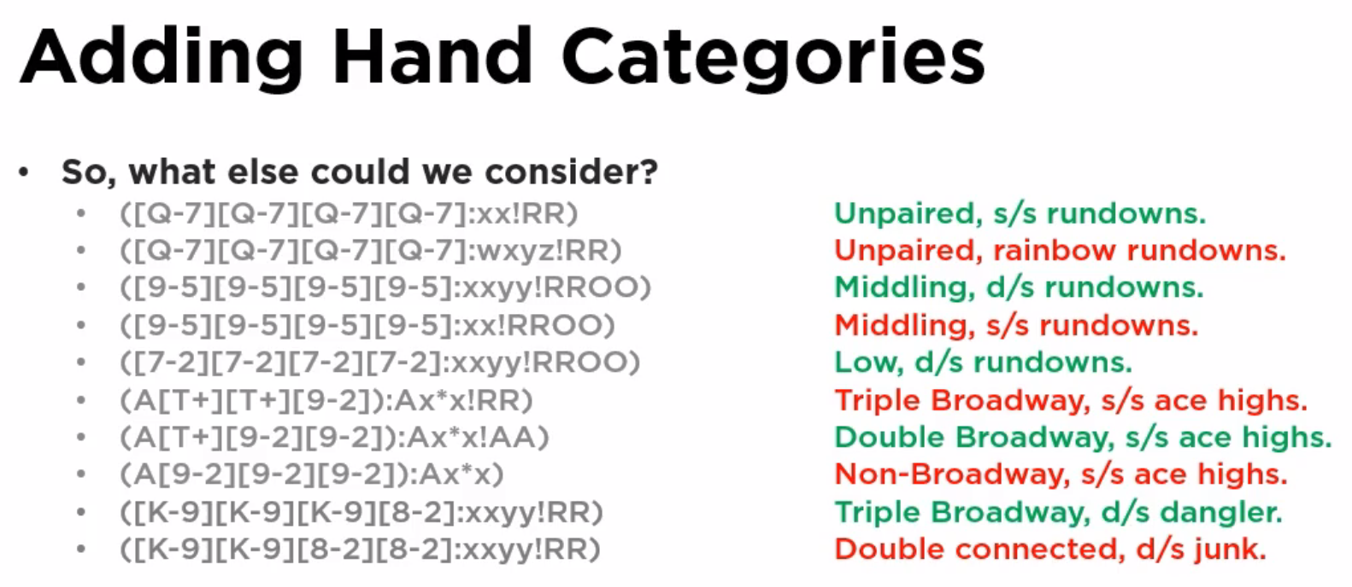

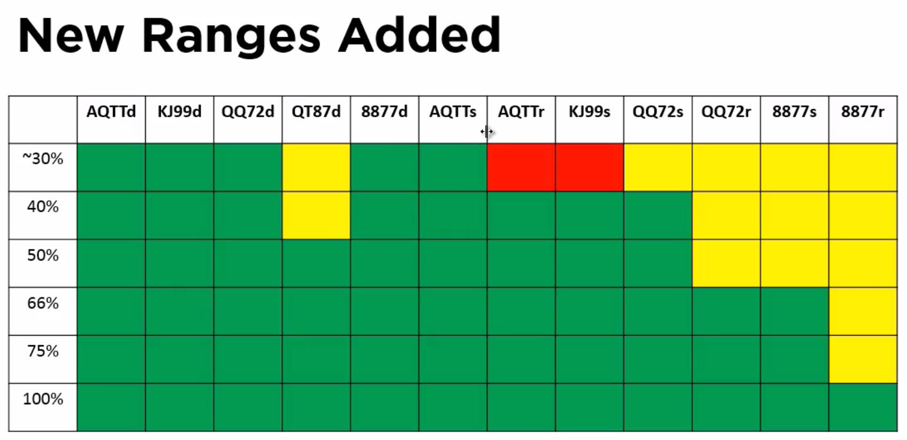

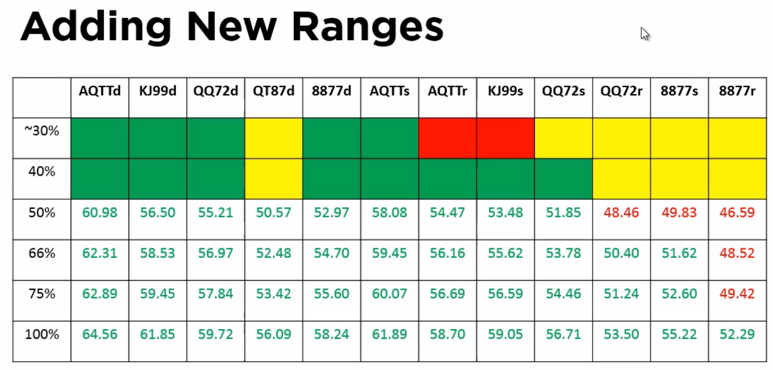

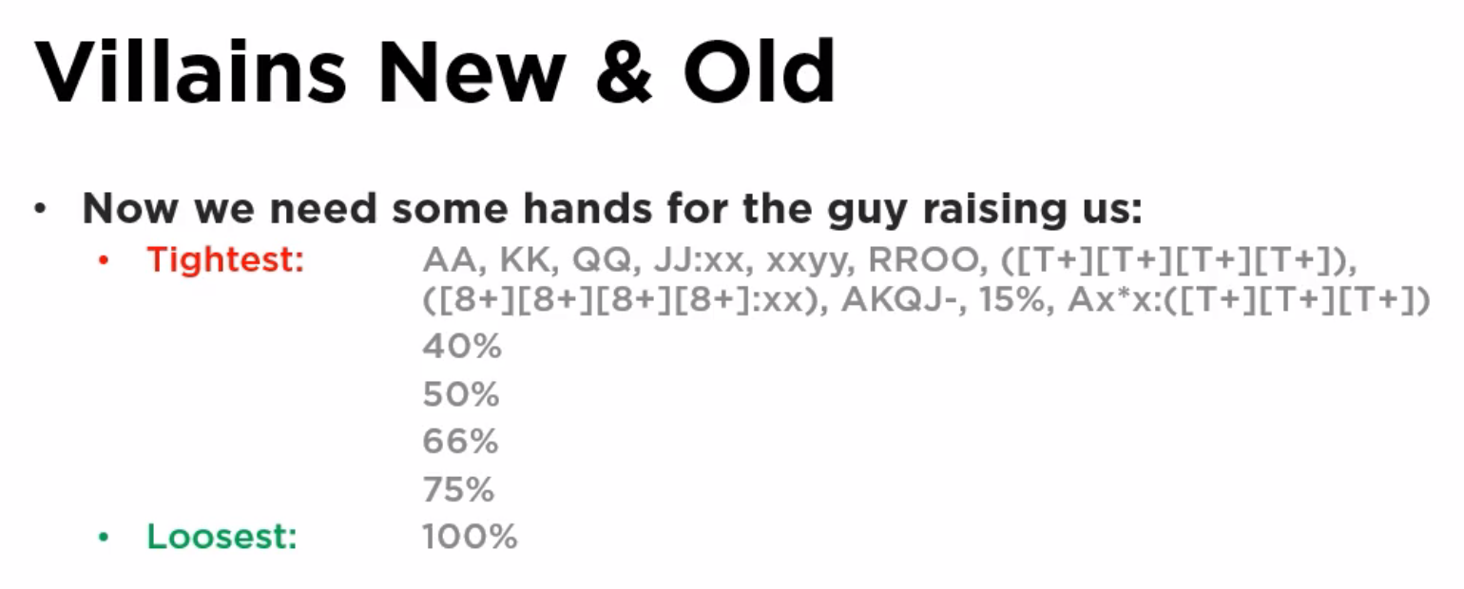

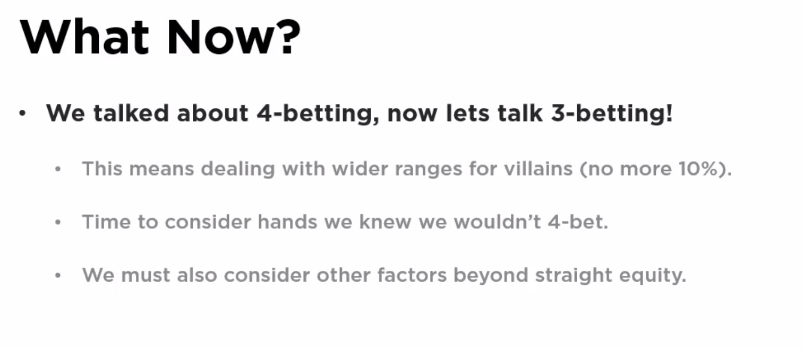

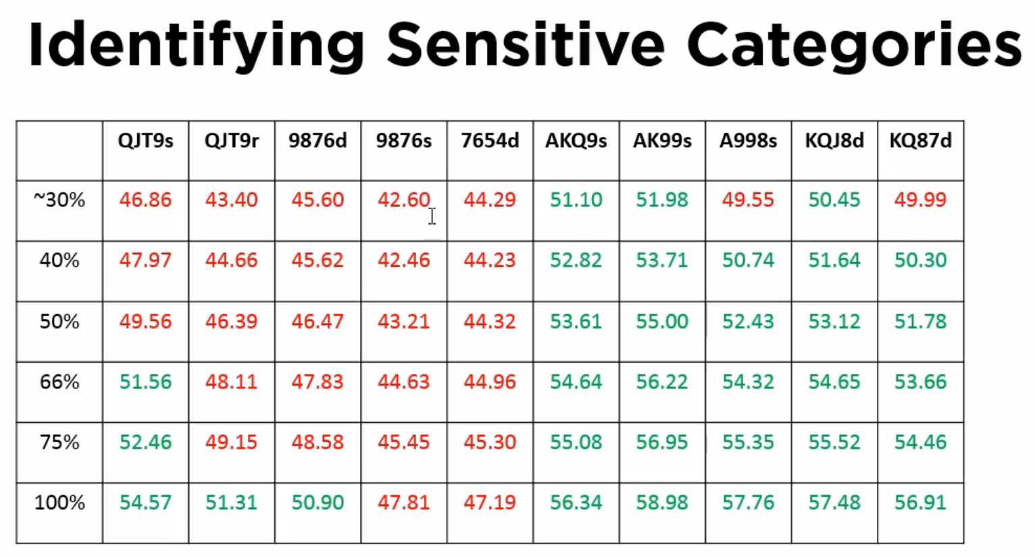



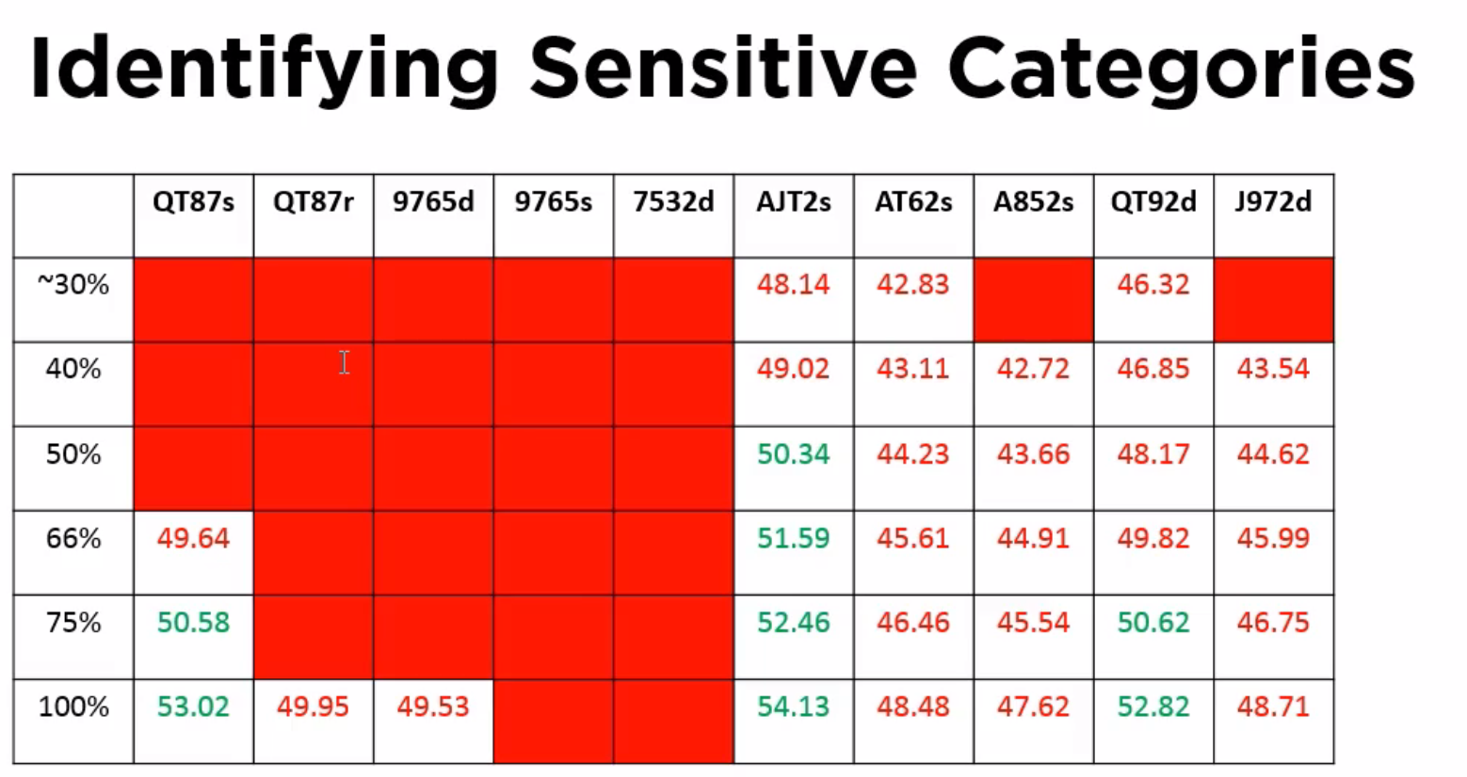

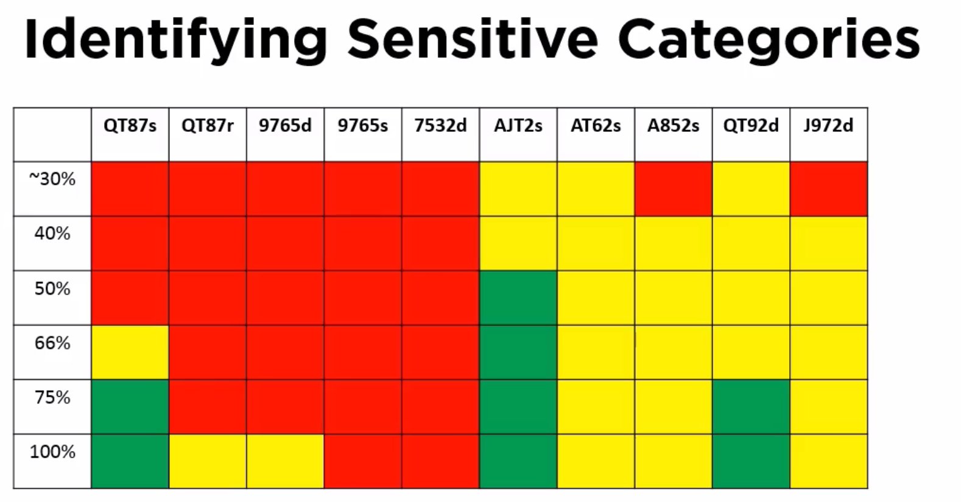

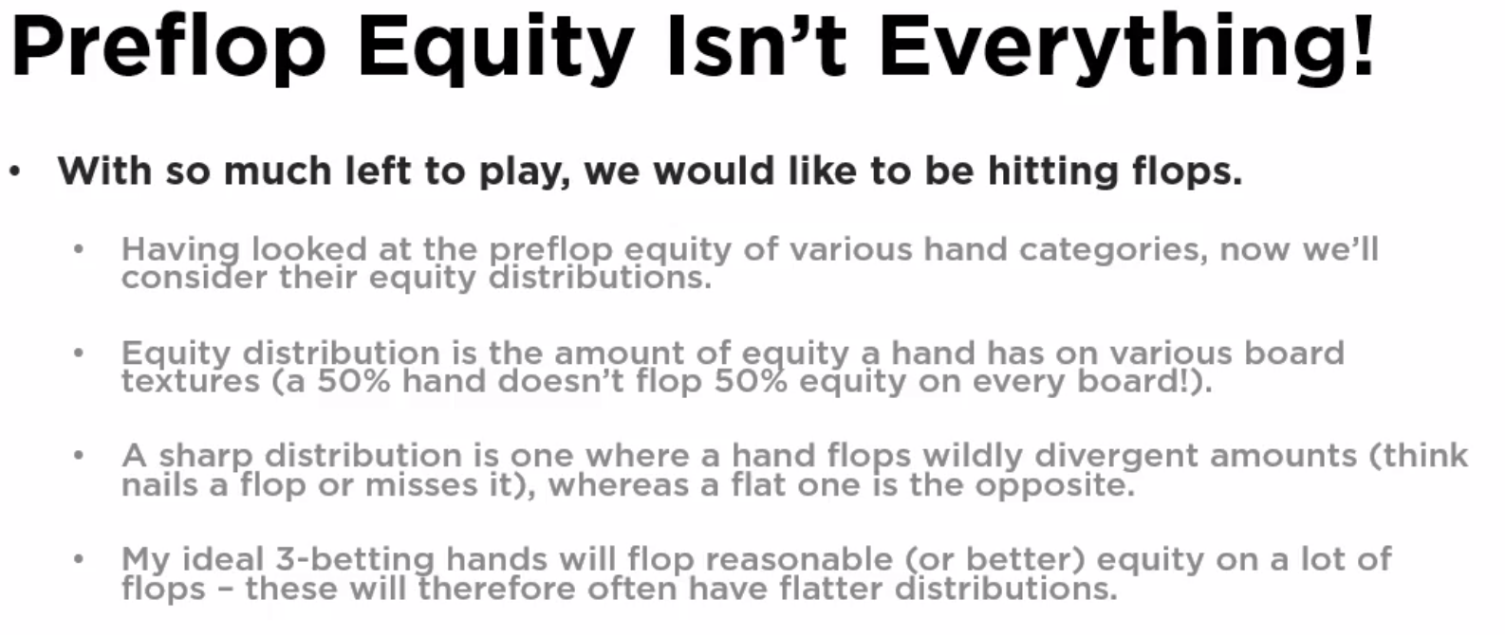

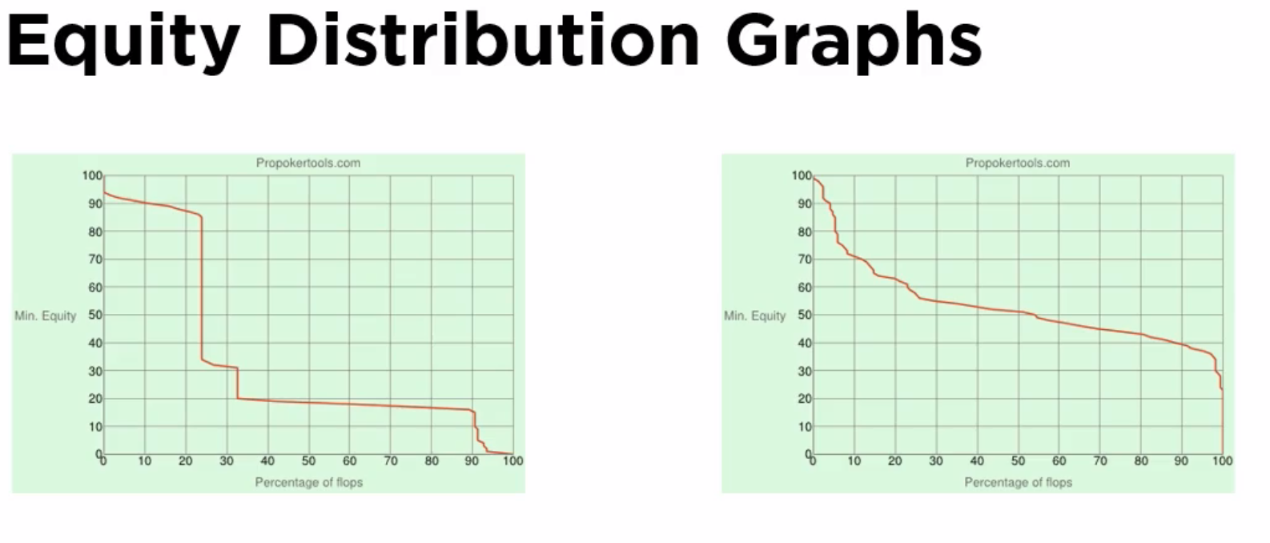

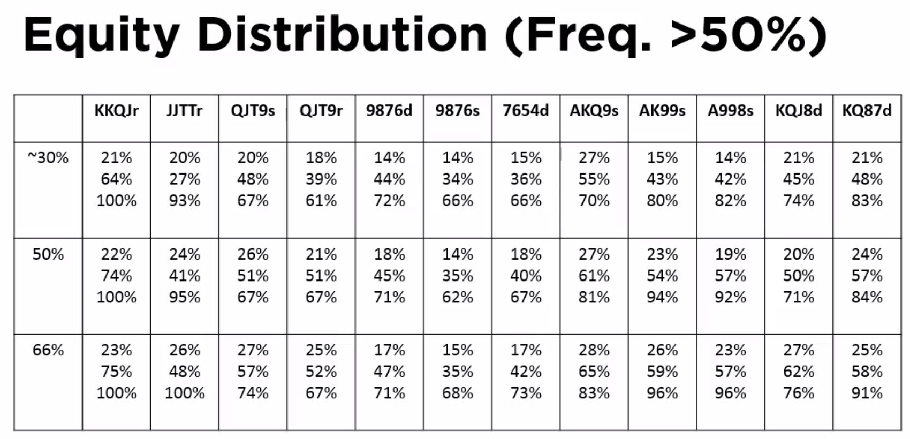

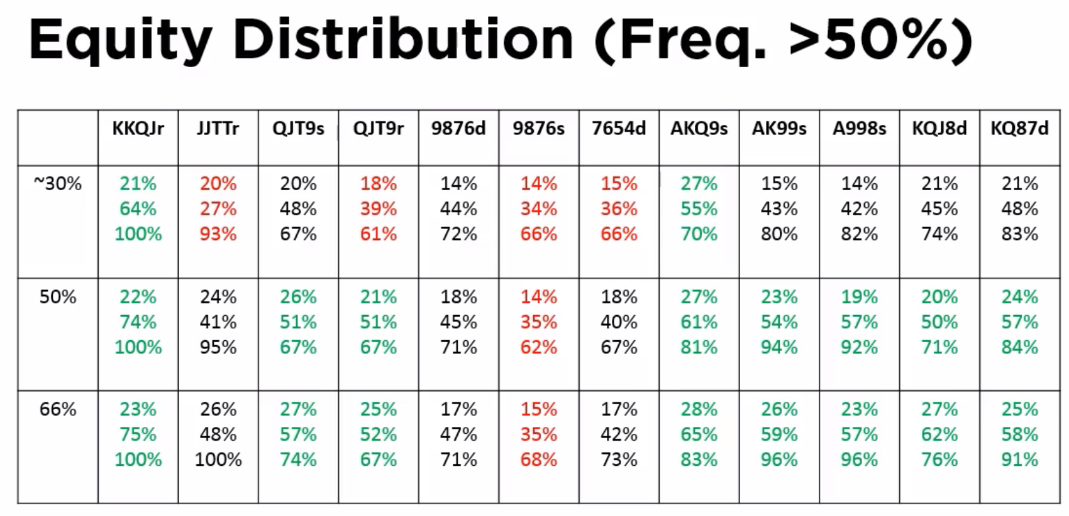

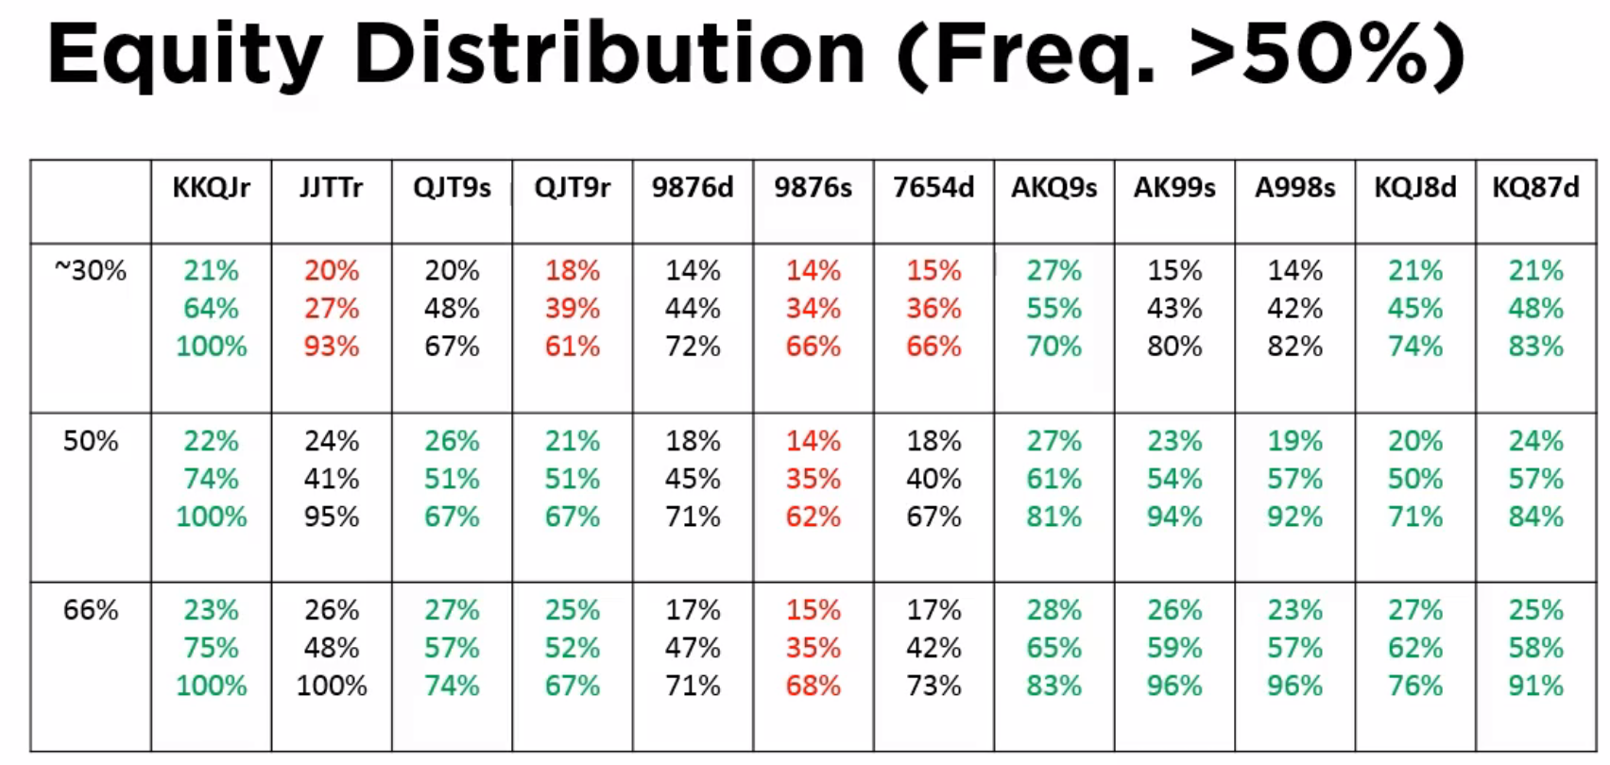

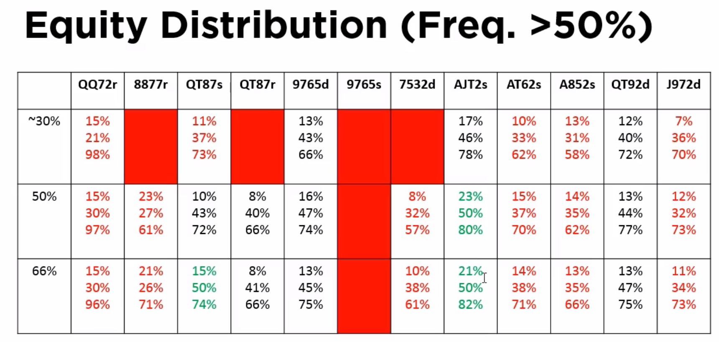

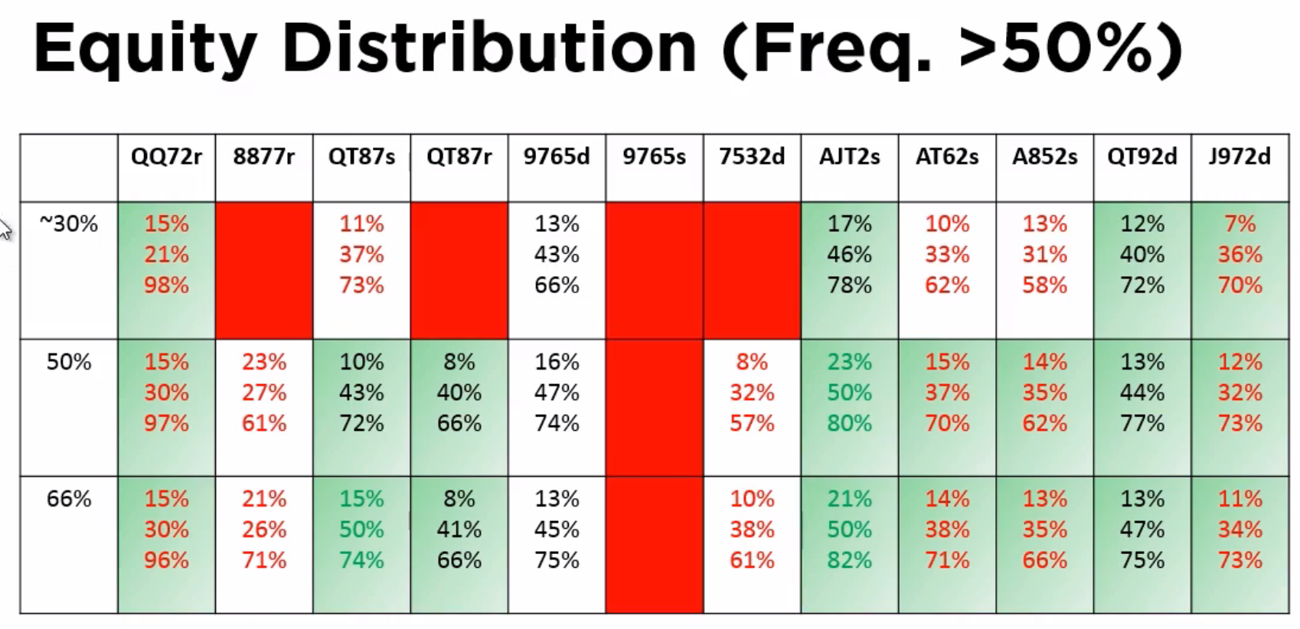

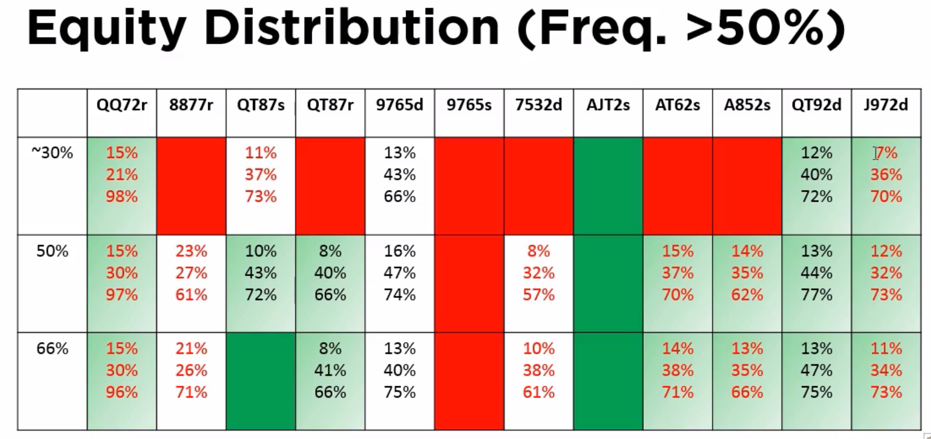

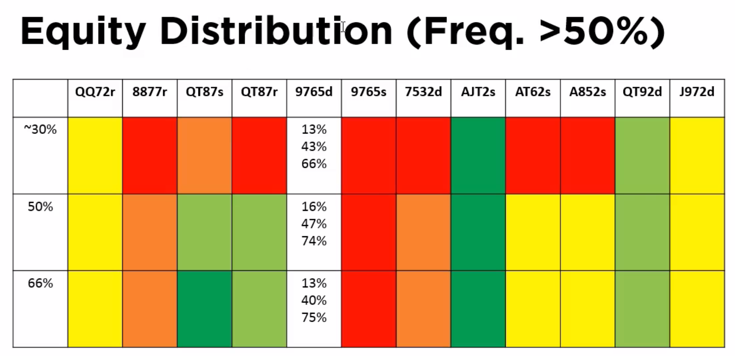

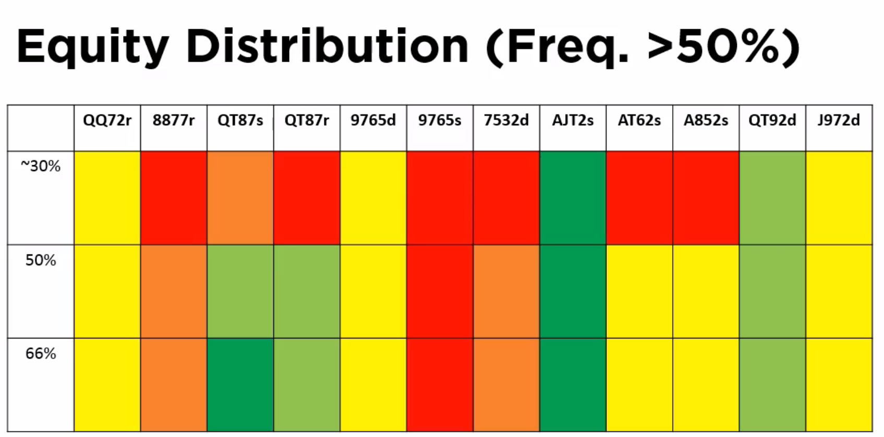

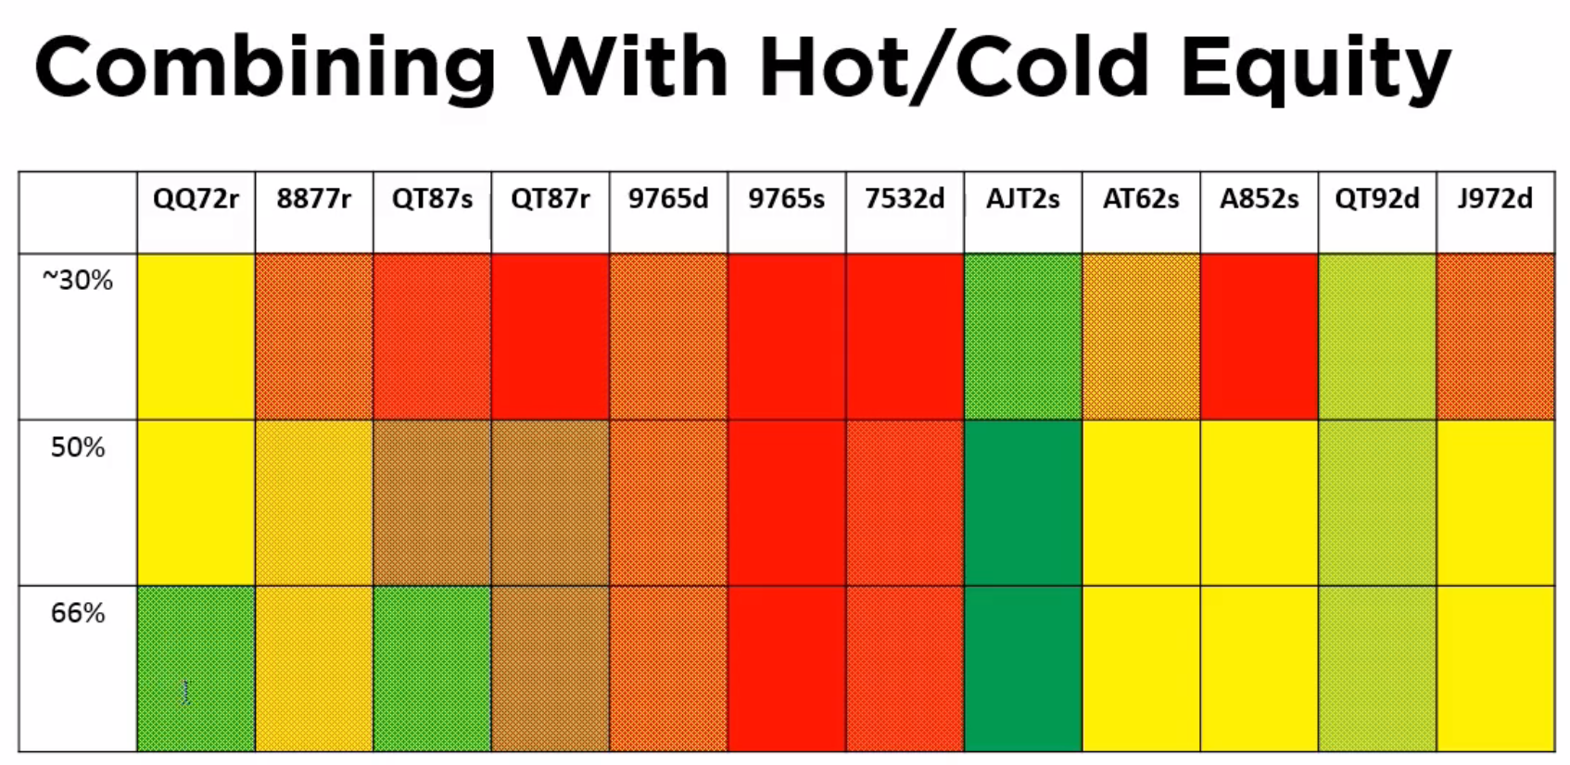

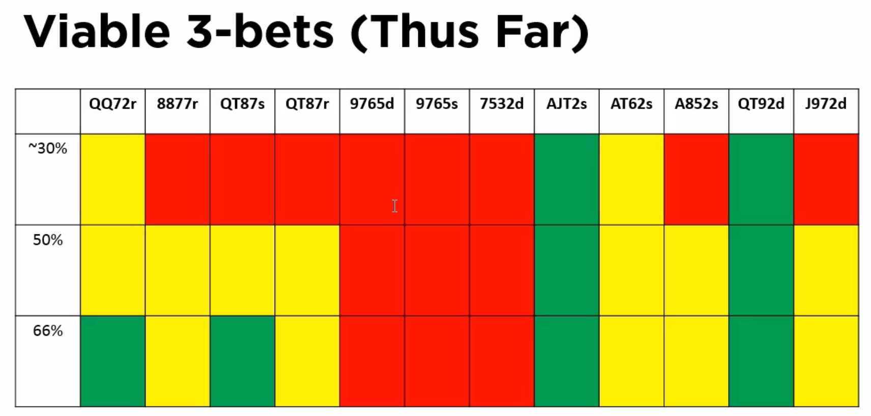

This is a test.

What sort of hands should be 3-bet. Harder than 4-betting

* Have to deal with wider ranges
* Need to consider things other than pre-flop equity
  + Post flop
  + Isolation considerations
  + Balance
  + Board coverage [less relevant for lower stakes]
  + Deception [less relevant for lower stakes]
* Villain ranges
  + Much wider, using coarse % ranges
  + Rainbow big pairs are still weak as are rainbow middle double-pairs
* Add new hand categories to test
  + 10 new categories
* Remove those hand categories that can’t push an edge
  + Being big and being paired is better than being connected
    - Triple broadway single-suited aces
    - Some high-card rundowns with a dangle
  + Lower rundowns do terribly all-in pre-flop
* Also important, is flopping equity (rather than all-in pre-flop equity)
  + Big cards have decent equity distributions on the flop
  + Double-suited hands doing well
  + Rundowns also doing well
* Looking at top and bottom of hand ranges
  + Single-suited uited aces and suited rundowns appear ok at both top and bottom of the range
  + Rainbow big pairs diverge, as are double-suited junk
* Fold-back in hot-and-cold equity
  + Also need to consider isolation (b/c some hands do well HU and poorly multi-way)
* What comes ou
  + Triple broady way single-suited
  + Double suited broadways with a dangler
  + Popular 3-bet hands doing badly
    - Double-suited middle-range rundowns
    - Not pushing an edge, but might be useful for Isolation and deception (board coverage)
* Begin to think about the reasons why were three betting, and why were selecting certain hands to 3-bet
* Have to convolve this information with reads/game flow/etc.